Name : Muhammad Owais
Reg No : FA24-BSE-054
Instructor : Sir Ehzaz Mustafa
Lab #4:

#Stack using arrays :
public class stack {
private static int maxSize;
int [] stackArray = new int[maxSize];
int top = -1;
public stack(int size){
this.maxSize = size;}
public boolean isEmpty(){
if(top==-1){
System.out.println("Stack is empty");
return true;}
else{
System.out.println("Stack is not empty");
return false;}}
public boolean isFull(){
if(top==maxSize-1){
System.out.println("Stack is full");
return true;}
else{
System.out.println("Stack is not full");
return false;}}
public void push(int value){
if(isFull()){
System.out.println("Stack is full, cannot push value");}
else{
top++;
stackArray[top]=value;
System.out.println("Pushed value: "+value);}}
public int pop(){
if(isEmpty()){
System.out.println("Stack is empty, cannot pop value");
return -1;}
else{
int value = stackArray[top];
top--;
System.out.println("Popped value: "+value);
return value;}}
public int peek(){
if(isEmpty()){
System.out.println("Stack is empty, cannot peek value");
return -1;}
else{
System.out.println("Top element is: "+stackArray[top]);
return stackArray[top];}}
public int size(){
return top+1;}
public static void main(String[] args) {
stack s = new stack(5);
s.isEmpty();
s.push(10);
s.push(20);
s.push(30);
s.push(40);
s.isFull();
s.peek();
System.out.println("Stack size is: "+s.size());
s.pop();
s.peek();}}

OUTPUT :
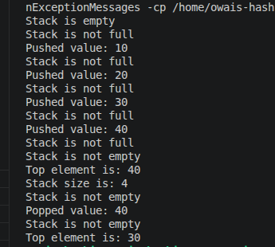

# Implement two stacks using one array :
public class two_stack {
int maxSize;
int [] stackArray ;
int top1;
int top2;
public two_stack(int size){
this.maxSize = size;
stackArray = new int[maxSize];
top1=-1;
top2=maxSize;}
public boolean isEmpty1(){
if(top1==-1){
System.out.println("Stack 1 is empty");
return true;}
else{
System.out.println("Stack 1 is not empty");
return false;}}
public boolean isEmpty2(){
if(top2==maxSize){
System.out.println("Stack 2 is empty");
return true;}
else{
System.out.println("Stack 2 is not empty");
return false;}}
public boolean isFull(){
if(top1+1==top2){
System.out.println("Stacks are full");
return true;}
else{
System.out.println("Stacks are not full");
return false;}}
public void push1(int value){
if(isFull()){
System.out.println("Stacks are full, cannot push value to Stack 1");}
else{
top1++;
stackArray[top1]=value;
System.out.println("Pushed value: "+value+" to Stack 1");}}
public void push2(int value){
if(isFull()){
System.out.println("Stacks are full, cannot push value to Stack 2");}
else{
top2--;
stackArray[top2]=value;
System.out.println("Pushed value: "+value+" to Stack 2");}}
public int pop1(){
if(isEmpty1()){
System.out.println("Stack 1 is empty, cannot pop value");
return -1;}
else{
int value = stackArray[top1];
top1--;
System.out.println("Popped value: "+value+" from Stack 1");
return value;}}
public int pop2(){
if(isEmpty2()){
System.out.println("Stack 2 is empty, cannot pop value");
return -1;}
else{
int value = stackArray[top2];
top2++;
System.out.println("Popped value: "+value+" from Stack 2");
return value;}}
public static void main(String[] args) {
two_stack ts = new two_stack(10);
ts.push1(1);
ts.push1(2);
ts.push2(9);
ts.push2(8);
ts.pop1();
ts.pop2();}}

OUTPUT :
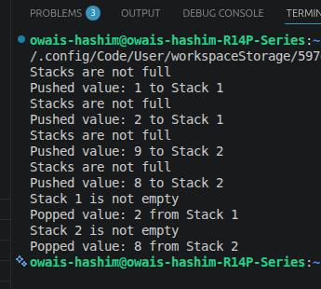

#Stack using Linked List :
class Node {
private int data;
private Node next;
public Node() {
data = 0;
next = null;}
public Node(int val , Node n) {
data = val;
next = n;}
public void setdata(int val){
data = val;}
public int getdata() {
return data;}
public Node getnext() {
return next;}
public void setnext(Node n) {
next = n;}}
public class linked_stack {
protected Node top;
protected int size;
public linked_stack(){
top = null;
size = 0; }
public boolean isEmpty(){
if(top == null){
System.out.println("Stack is empty");
return true;}
else{
System.out.println("Stack is not empty");
return false;}}
public int getSize(){
return size;}
public void push(int value){
Node newNode = new Node(value, top);
if(top == null){
top = newNode;
} else {
newNode.setnext(top);
top = newNode;}
size++;}
public int pop(){
if(isEmpty()){
System.out.println("Stack is empty, cannot pop value");
return -1;}
else{
int value = top.getdata();
top = top.getnext();
size--;
System.out.println("Popped value: "+value);
return value;}}
public int peek(){
if(isEmpty()){
System.out.println("Stack is empty, cannot peek value");
return -1;}
else{
System.out.println("Top element is: "+top.getdata());
return top.getdata();}}
public void display(){
if(isEmpty()){
System.out.println("Stack is empty, cannot display values");}
else{
Node current = top;
System.out.print("Stack elements: ");
while(current != null){
System.out.print(current.getdata() + " ");
current = current.getnext();}
System.out.println();}}
public static void main(String[] args) {
linked_stack ls = new linked_stack();
ls.push(10);
ls.push(20);
ls.peek();
ls.pop();
ls.peek();
ls.display();}}

OUTPUT :
